Name : THEJA BODDU Contact No : 9912054321

CMD: mkdir

Description: we can create new folder in home page // any one of the folder..here we can use this command “MKDIR”

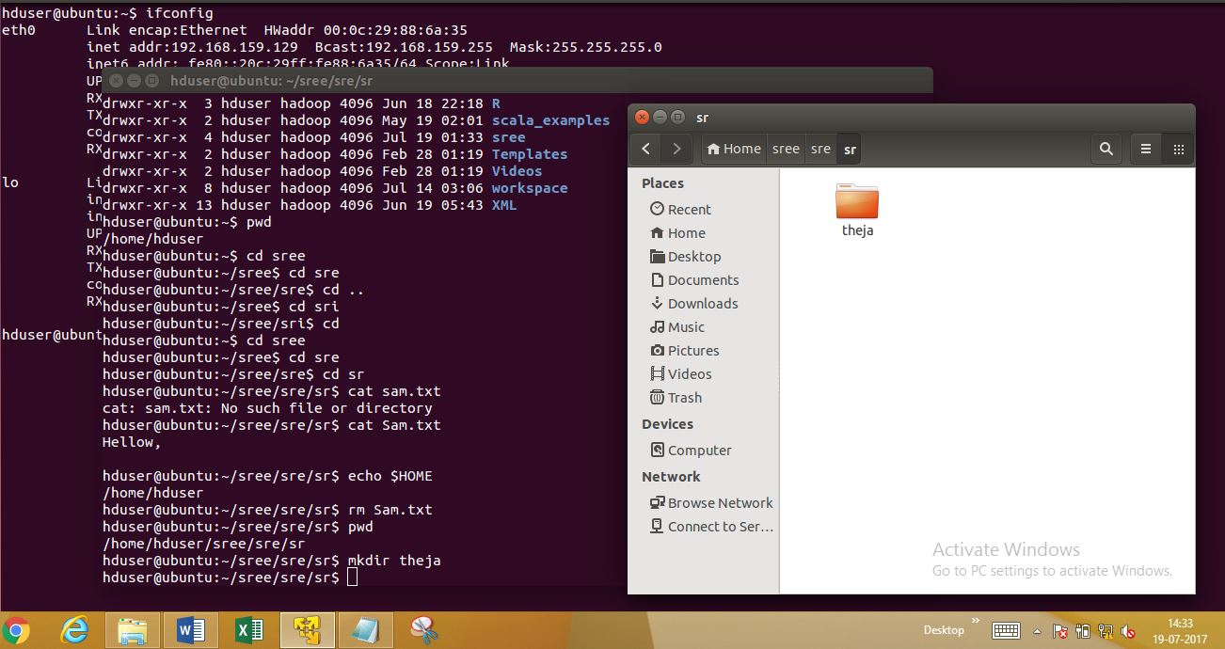

CMD: ls -l

Description: for extra information about our folders & list of contents will be available

command “ls -l”

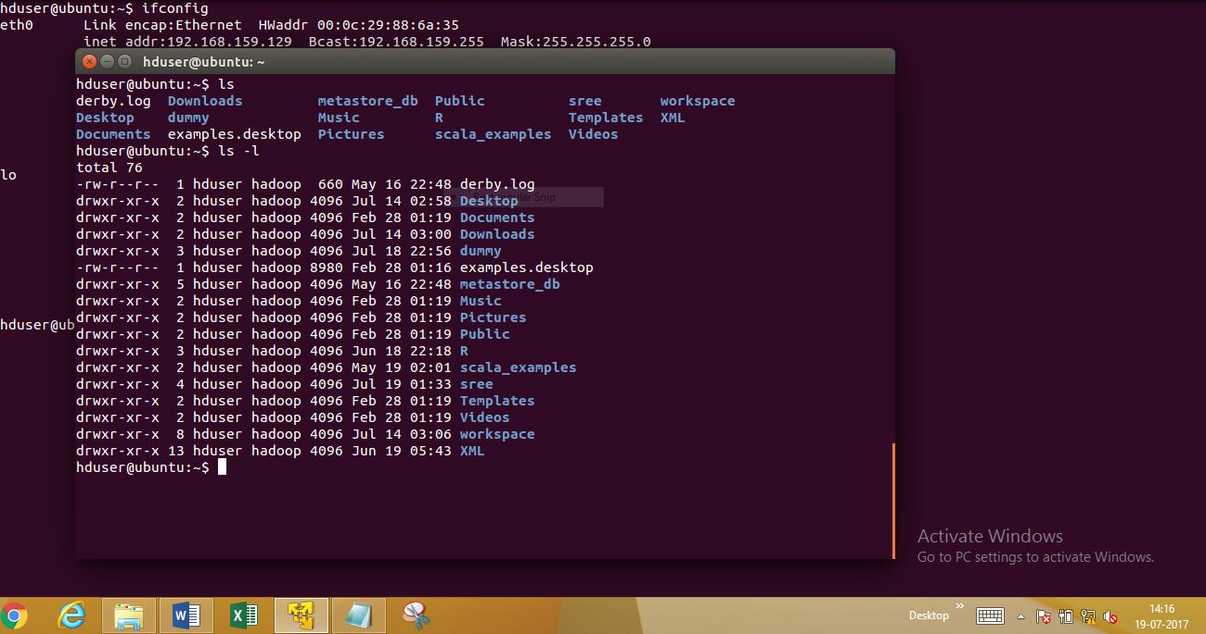

CMD: PWD

Description: which directory we are currently working is shown by this cmd

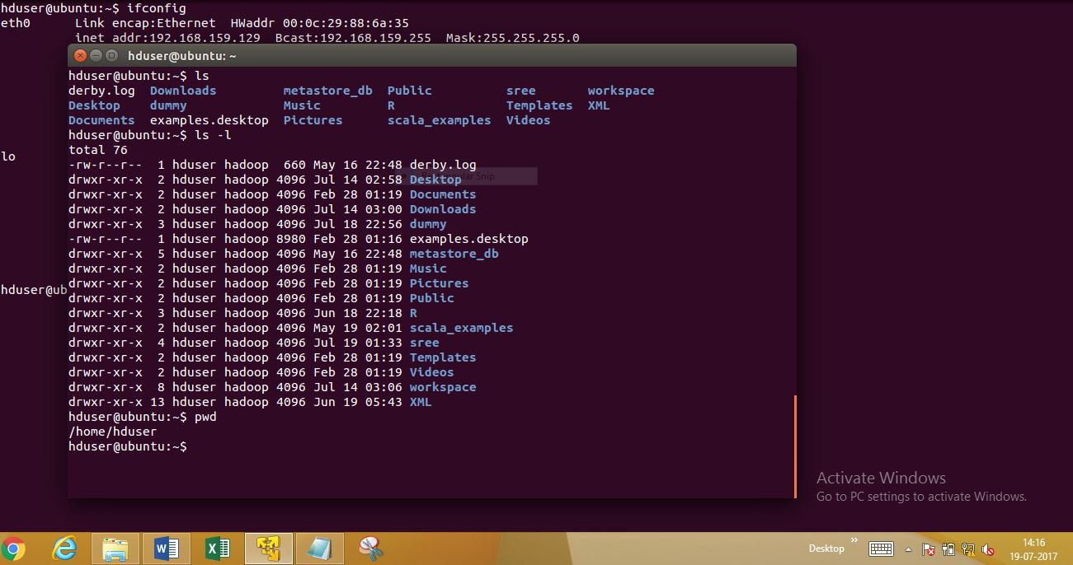

CMD: CD

Description : main purpose of this CD command is to return back to home directory

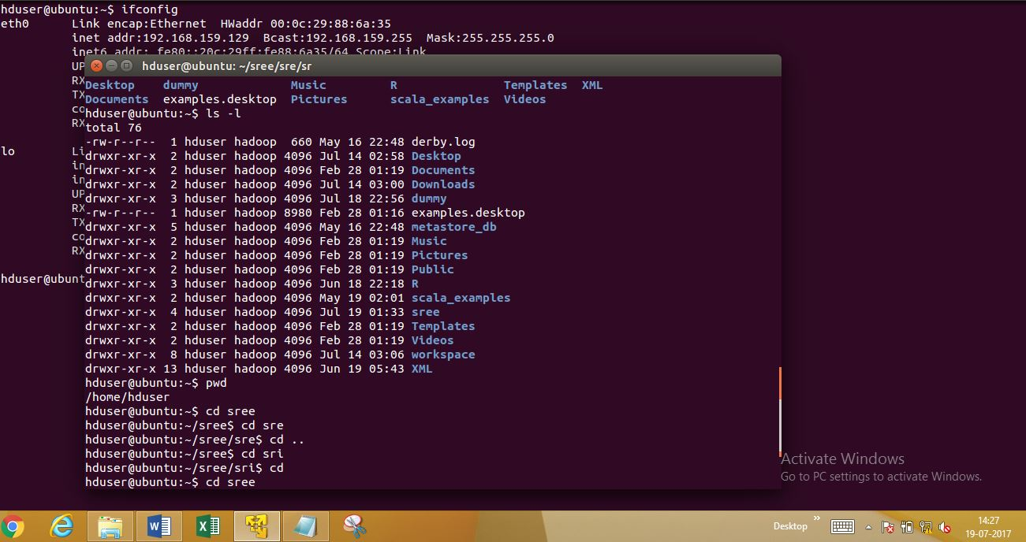

CMD: cd ..

Description: one level backward in any situations [home directory can go one step back[

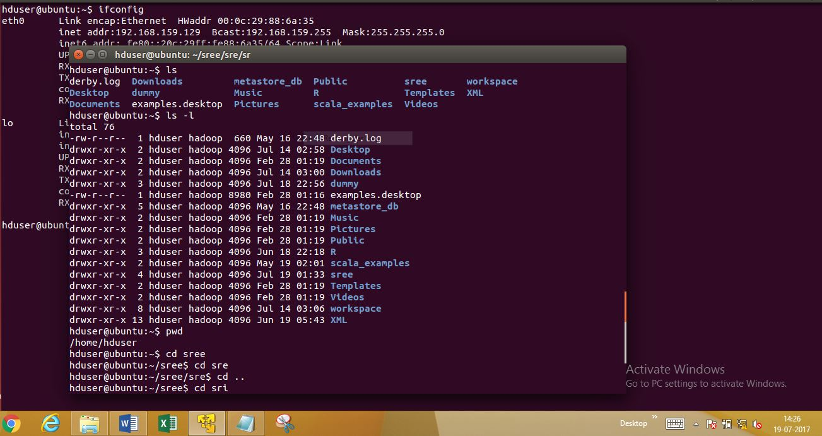

CMD : cat

Description: in any file when we get information about content here display will be appear

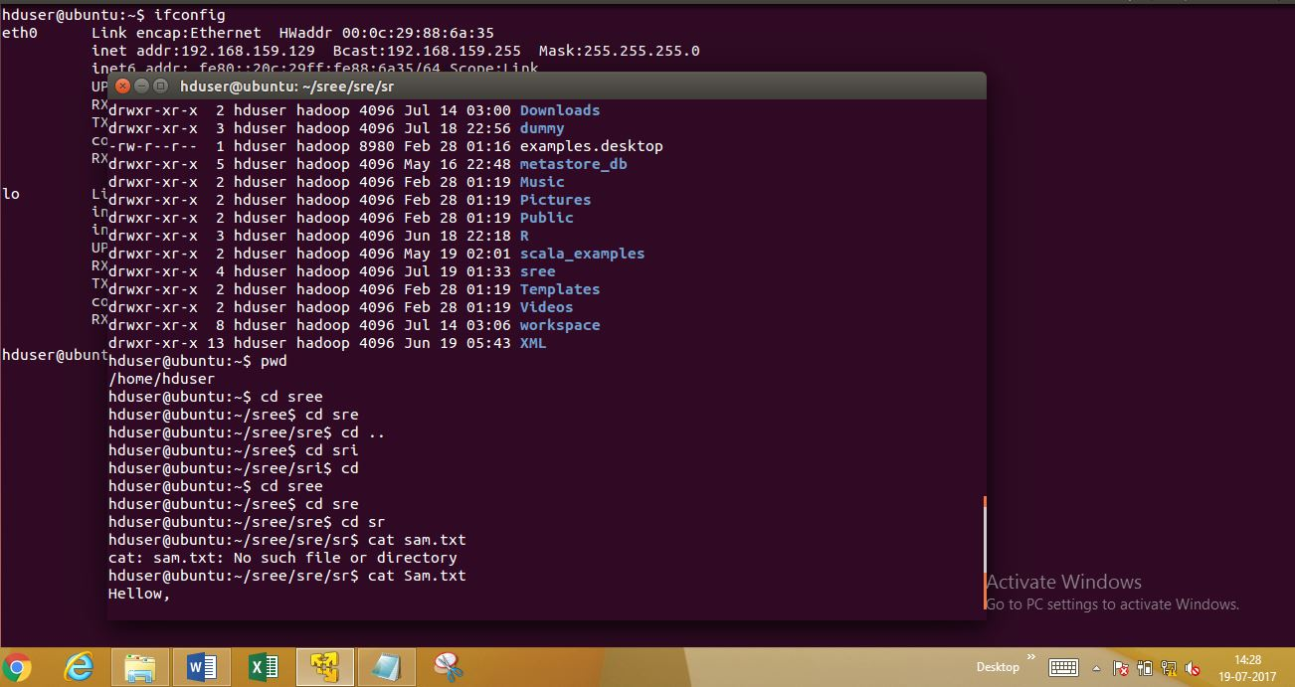

CMD: PWD

Description: which directory we are currently working is shown by this command PWD

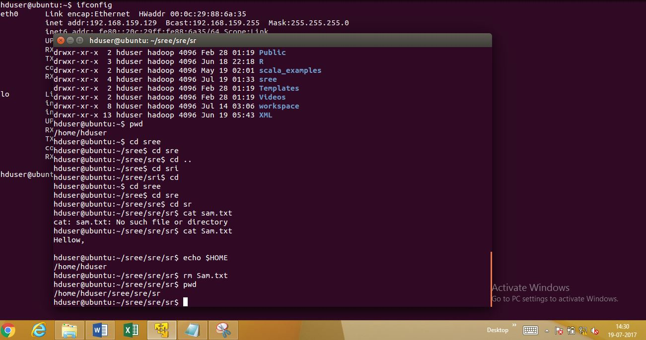

CMD: rm

Description: remove a file from any folder in that situations we will use this command rm

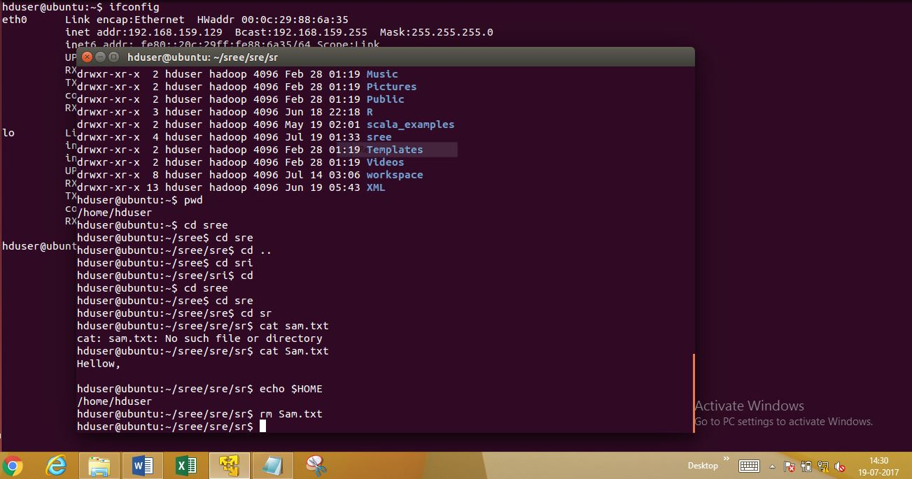

CMD: mv {move folder}

Description: if sometimes we can do change the location of one folder to another that time it will helps “mv” command

**Mv sre/lord sri**

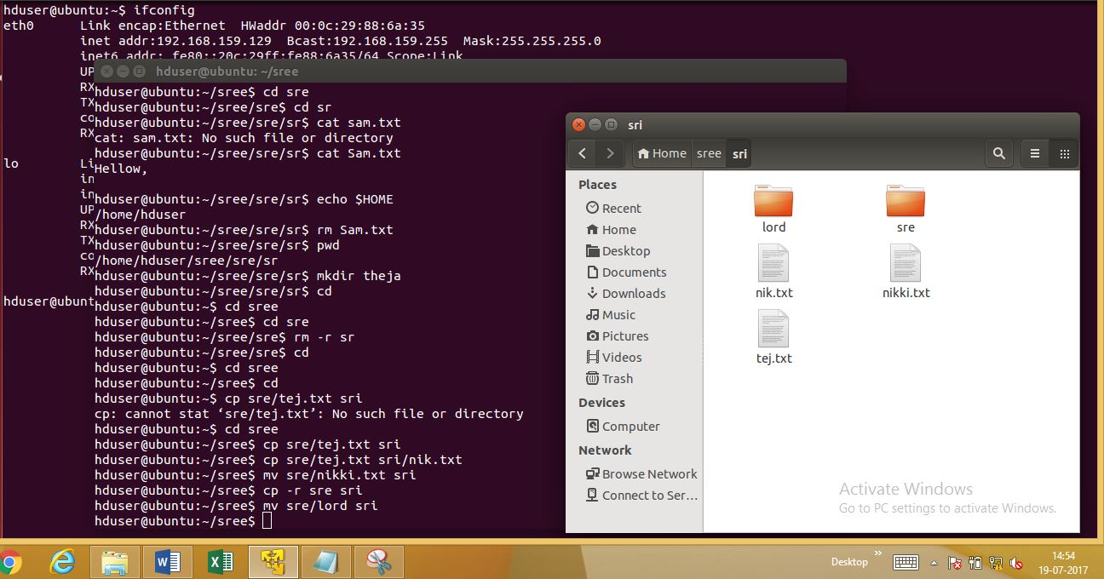

CMD: cp

Description: can copy from one folder to another folder in some files [here we can use this “cp” command]

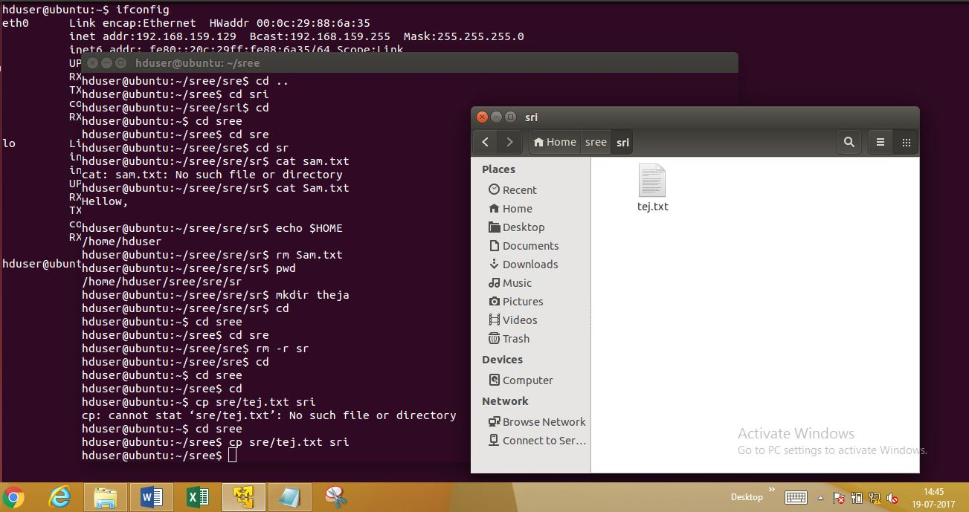

CMD: Cp & rename the file

Description: if we can change the name & copy the file at one time ,[that situations we will use this command]

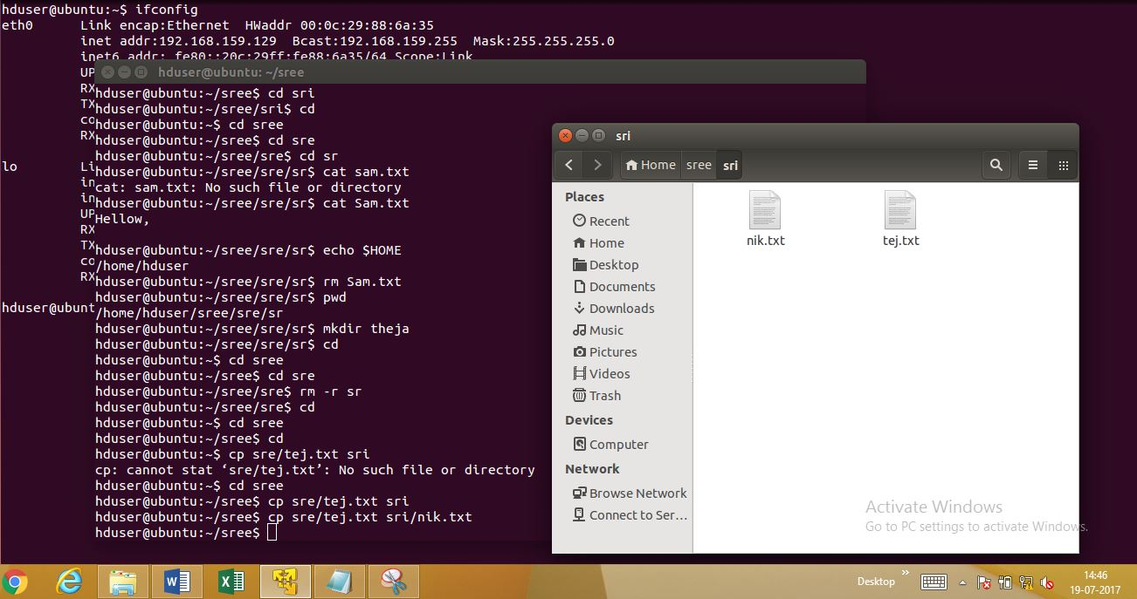

CMD: Cp (Copy folder)

Description: copy another folder

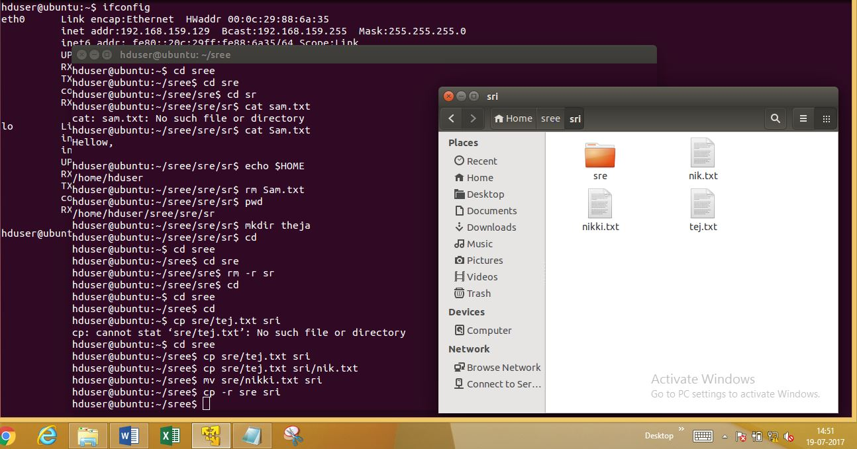

CMD: rm -r

Description: Delete files & folders in selected folder

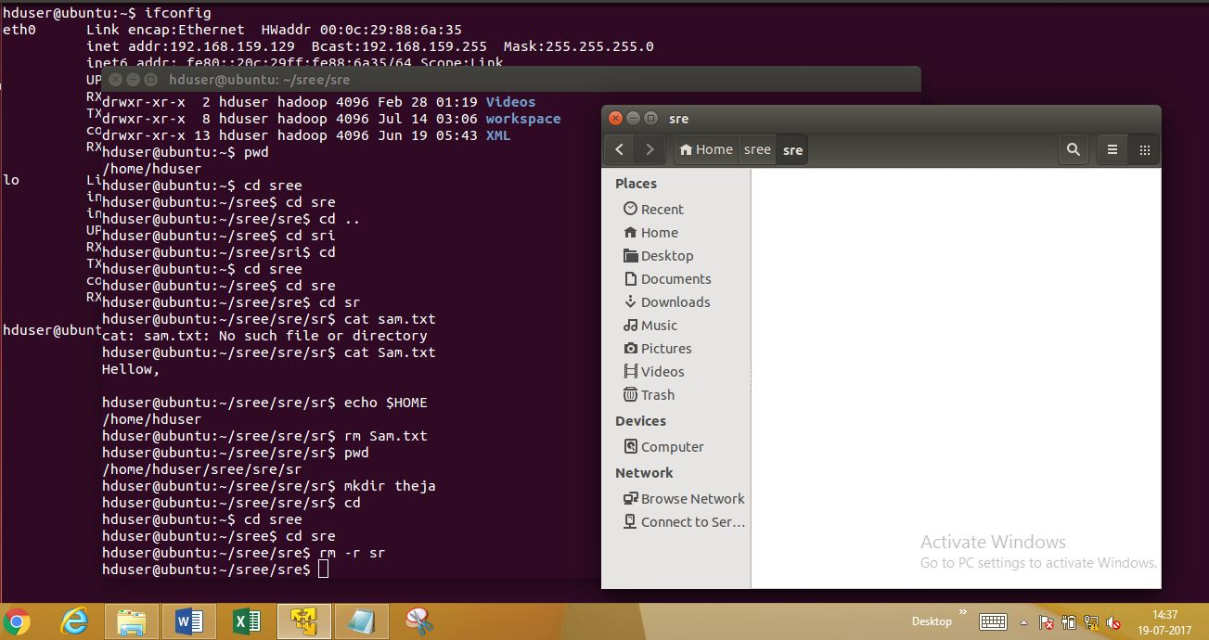

CMD: mv [move files]

Description: can move from one folder to another folder in one or more files [here we can use this “mv” command]

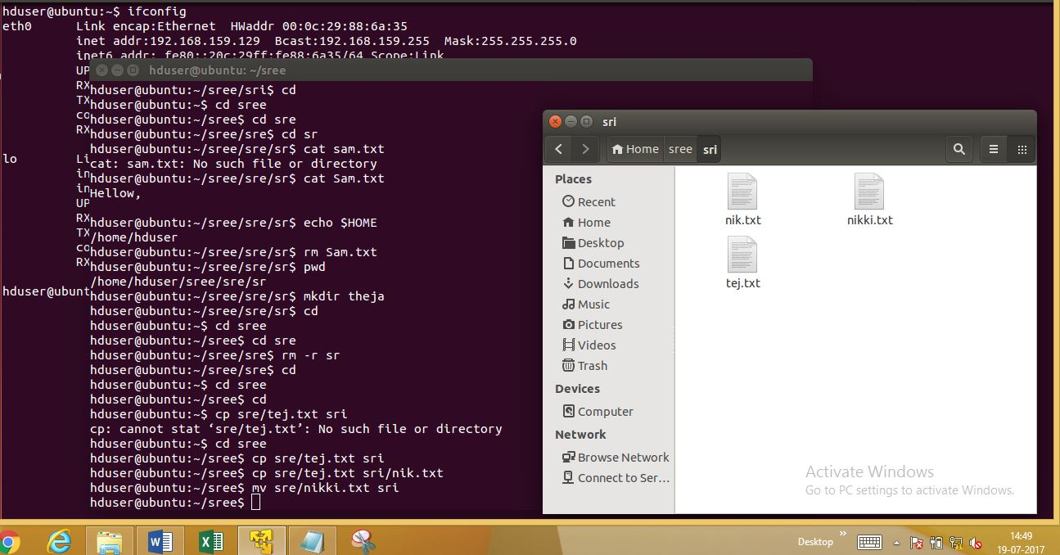

CMD: ls

Description: list of folders will be shown by the command “LS”

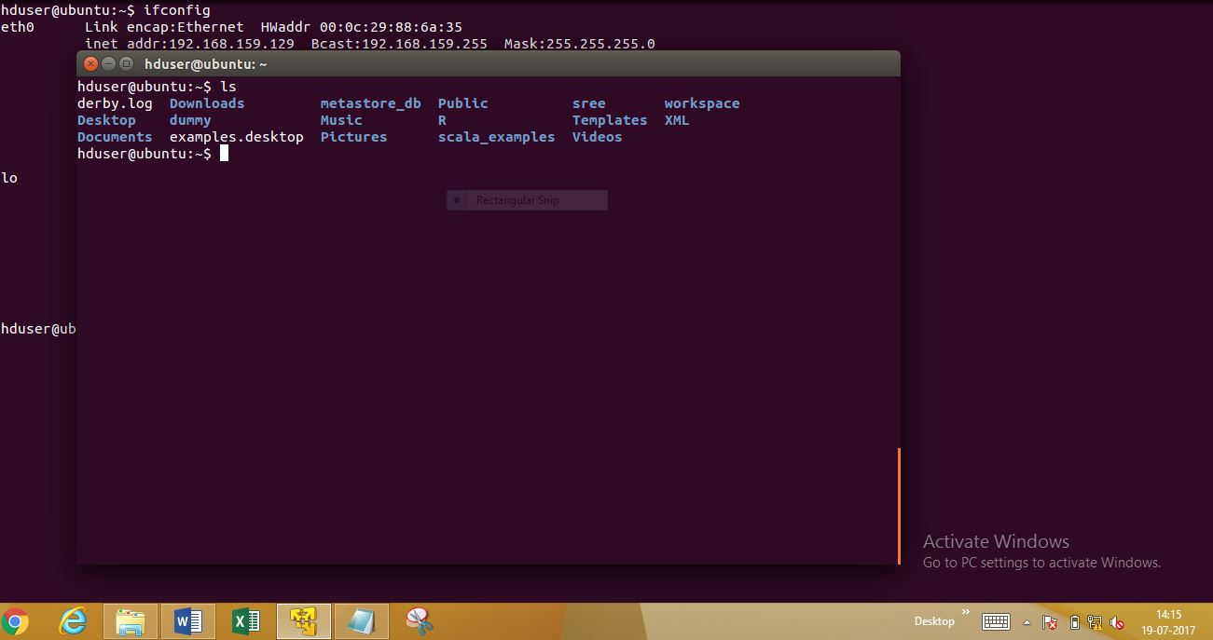

CMD: Clear

Description: clear all commands from page

